**COLLEGE OF BUSINESS EDUCATION**



**DODOMA CAMPUS**

*Student’s Name:* **FACKIRY JUMANNE JUMAKATOTO**

Reg no: **03.0179.01.01.2022**

***Course* : BIT**

***Lecturer*:madam ATUPELE CAIRO MWAITETE**

***Subject:* PROGRAMMING IN JAVA**

***Nature of Work:* INDIVIDUAL ASSIGNMENT**

**Question.**

You are required to create a small Java application that addresses an everyday challenge faced by individuals or communities in Tanzania with a theme of **"Digital Solutions for Everyday Challenges in Tanzania"**. Each student should select a specific challenge and provide a software-based solution.

**Report Title: Online Shopping System for Fanka’s Shopping Center**

**1. Introduction**

In the rapidly growing digital era, online shopping platforms have become an essential part of our daily lives. This report presents an online shopping system created for "Fanka’s Online Shopping Center" that allows customers to browse and purchase items, including T-shirts and hats. The system was developed using Java and Swing, providing an easy-to-navigate graphical user interface (GUI) for shopping.s

**2. Project Objective**

The goal of this project was to design and implement an online shopping system that enables users to:

* Browse categories of products (T-shirts and hats).
* View detailed product information, including images and prices.
* Add products to the cart and make payments.
* Receive an order receipt and thank you message after a successful transaction.

**3. System Features Implemented**

* **Category Selection:** The user can choose between two categories: T-Shirts and Hats. Each category is represented with a button that shows an image and label.
* **Product Display:** Upon selecting a category, the user is presented with a grid layout of products, showing images, names, and prices of each product.
* **Add to Cart:** Users can click on any product to specify a quantity. The selected products are added to a cart.
* **Total Calculation:** The system calculates the total cost based on the selected products and displays it.
* **Payment and Receipt:** Users can make a payment by entering the amount. After payment, a receipt is shown with a breakdown of the purchased items, their costs, the total cost, and the change.
* **Thank You Message:** After a successful purchase, a message is shown to the user, thanking them for shopping and encouraging them to visit again.

**4. Screenshots**

***Include screenshots of the following stages in your system:***

1. **Category Selection Screen:** A screenshot showing the main screen with buttons for "T-Shirts" and "Hats" categories.

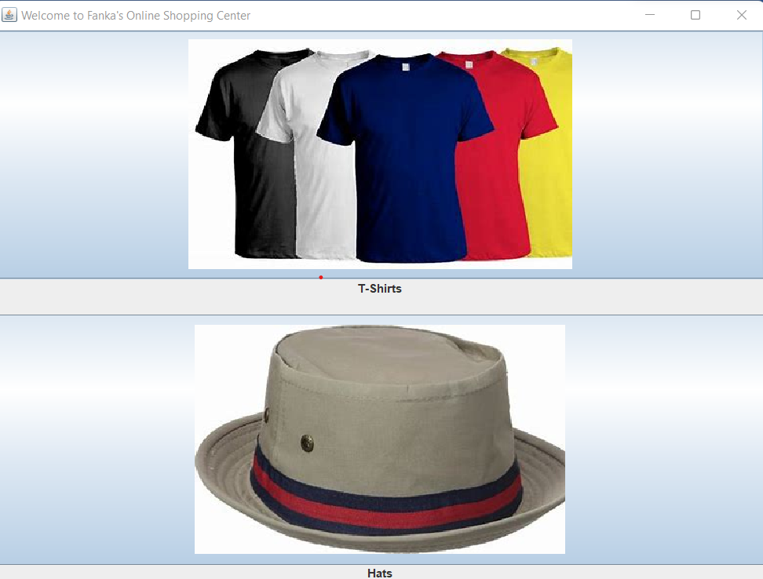

1. **Product Selection Screen:** A screenshot showing the products in a selected category with images, names, and prices.

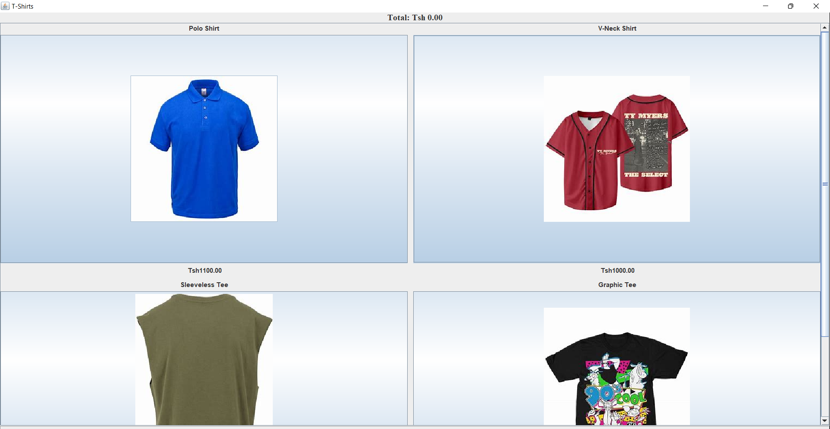

1. **Cart and Total Display:** A screenshot showing the total cost of selected products and the payment button.

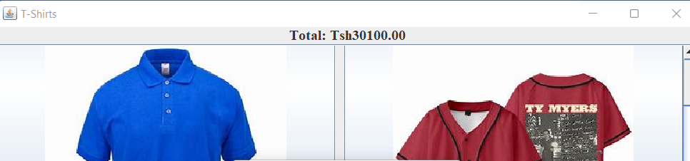

1. **Payment Process:** A screenshot showing the payment interface where users input their amount.

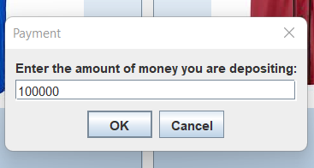

1. **Receipt Screen:** A screenshot of the receipt after successful payment, including the order details and change.

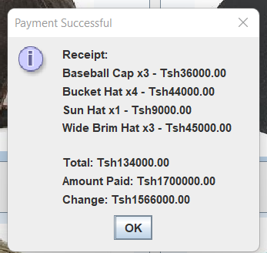

**5. Challenges Faced During Development**

* **Handling Multiple Categories:** Initially, I had trouble setting up a flexible structure for handling different product categories (T-shirts, Hats). The solution was to use two separate HashMap objects to store the products for each category.
* **Image Loading and Path Management:** Ensuring that images were loaded correctly from the local folder was another challenge, especially when testing on different systems. The solution was to use relative paths for image loading.
* **Quantity Input Validation:** Ensuring that the user entered valid quantities when adding products to the cart was tricky. I used JOptionPane.showInputDialog and then validated the input to ensure it was a positive integer.
* **Updating the Total Dynamically:** Calculating and updating the total cost dynamically as the user adds products to the cart required careful management of the selectedProducts map. I used streams to calculate the total cost based on the selected items.
* **Payment Processing and Change Calculation:** Handling the payment process and ensuring that the user was able to enter a payment amount and get the correct change required multiple tests to ensure accuracy.
* **GUI Layout Design:** Initially, the layout of the user interface did not look well-aligned, especially the product grid. I used GridLayout for the category selection screen and adjusted the BorderLayout for individual product display screens to resolve this issue.

**6. Conclusion**

The system was successfully developed and provides a functional online shopping experience. Users can browse products, select them, and make payments with ease. The project serves as a stepping stone for developing more advanced online shopping systems with additional features such as user login, shopping history, and inventory management. It demonstrates my understanding of Java programming, GUI design, and payment handling.

**7. Future Improvements**

* **User Authentication:** Adding user authentication (login and registration) would allow customers to save their preferences and order history.
* **More Product Categories:** Additional categories such as shoes, accessories, and electronics could be added to expand the shopping experience.
* **Online Payment Integration:** Integration with real-world payment gateways would make the payment process more realistic.

**8. References**

* **Java Documentation:** For information about the Java language and libraries used.
* **Swing Tutorials:** To help understand the use of Swing components.
* **JOptionPane Documentation:** To learn about how to use dialog boxes in Java.